Minutes of Meeting

March-2022

1-: In March 86 total NIKSHAY ID were generated.

2-: 25 patients were started ATT.

3-: World TB Day celebration on 24th March in Hospital campus with participate of all MBBS and Nursing students.

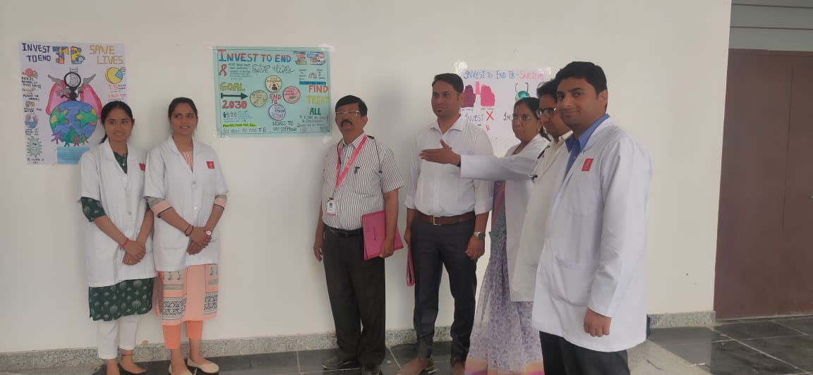

4-: Dr.Malkesh Meena presented PPT on world TB Day whose topic was “INVEST TO END TB”.

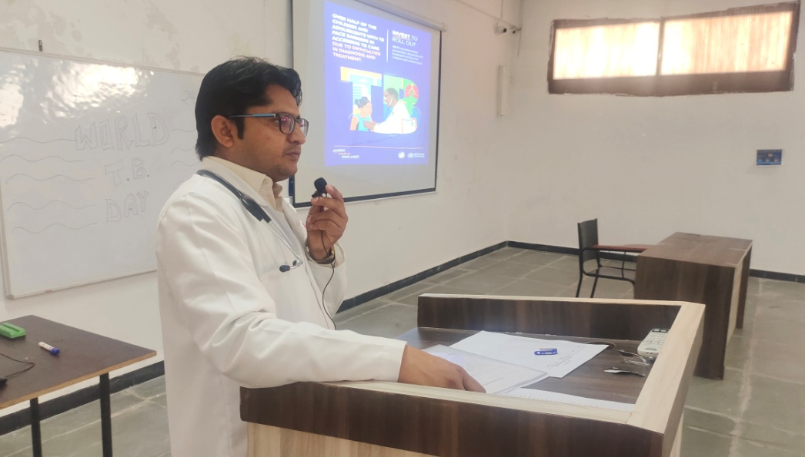

5-: Social message regarding spread and prevention of TB given to students on subject “ INVEST TO END TB”

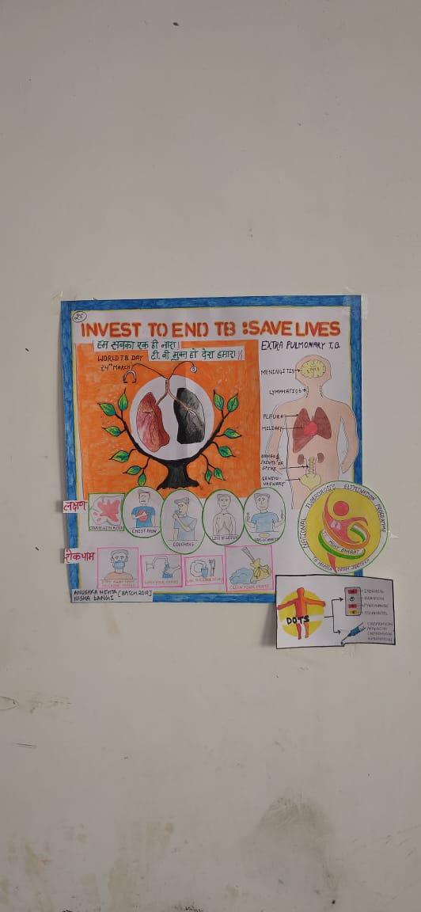

6-: Ananta Hospital Felicitad at state level ceremony jaipur by Dr. V.K.Garg (STO) and Dr. V.K. Mathur (D.M. & H.D.) on 22nd March for out standing private sector participating program in district level and attend by Dr. Kunal Pandya (MOTB)

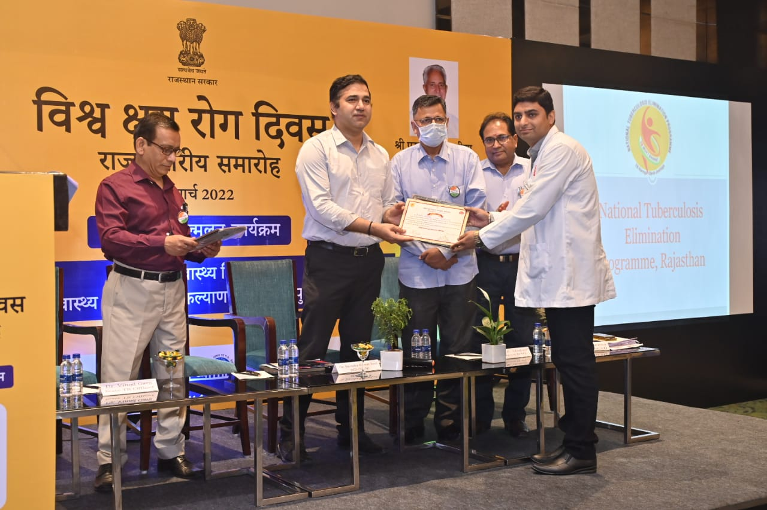

7-: 25 March Dr.Manoj Jani (Associate Professor) and Dr. Kunal Pandya (MOTB) attented TB Day function were felicited by Dr Hemant Bindal (DTO) , DR Prakash Chand Sharma ( CHMO) and Nilab Saxena ( Dis. Collector) at Kamla Nehru Hospital Rajsamand.

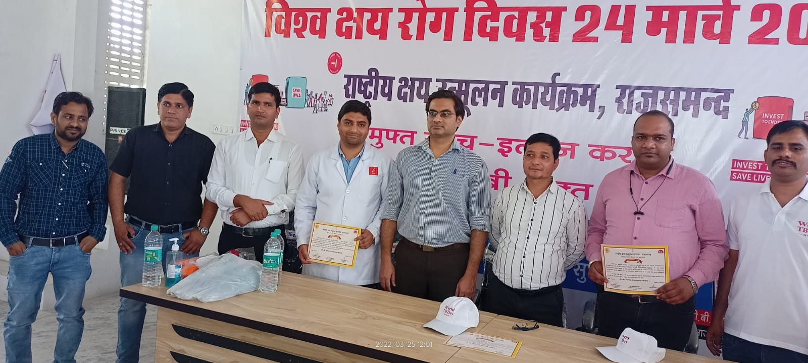

8-: 26 March Dr.Kunal Pandya ( MOTB) and LT Nirmala Sen (LT) attended function were felicited by Dr. Khushwant Jain at Khamnor Block Rajsamand.

